Question 4 [6 Points]
Create a shell script emailcleaner.sh that processes emails.txt.
• Extract all valid email addresses and store them in valid.txt
• Extract invalid email addresses and store them in invalid.txt
• Remove duplicate entries from valid.txtValid email format:<letters_and_digits>@<letters>.comUse grep, sort, uniq, and redirection.
----
Script
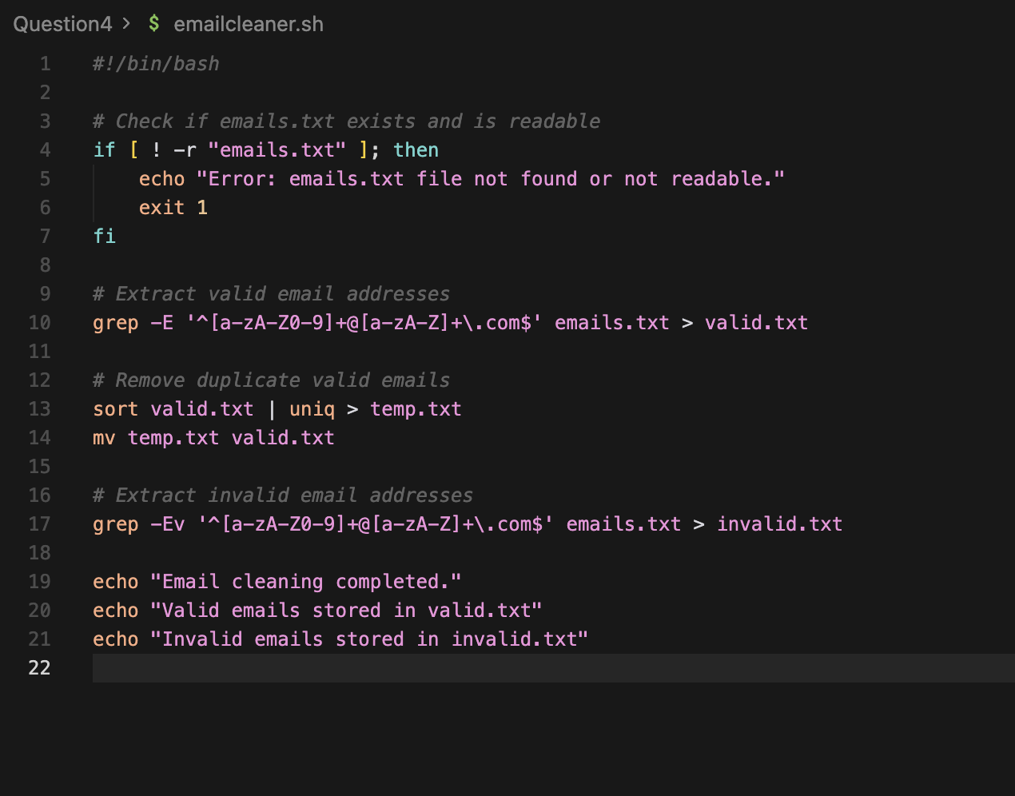
Explanation:
grep -E '^[a-zA-Z0-9]+@[a-zA-Z]+\.com$' emails.txt > valid.txt:
grep : Searches texted based on a pattern
-E - enables Extnedted Regular Expressions
'^[a-zA-Z0-9]+@[a-zA-Z]+\.com$' : (This is regex pattern for valid emails)
In conclusion:
The script validates emails addresses using grep with regular expressions, removes duplicates using sort and uniq, and stores valid and invalid emails into separate files using redirection.
Output:
